Quick Example
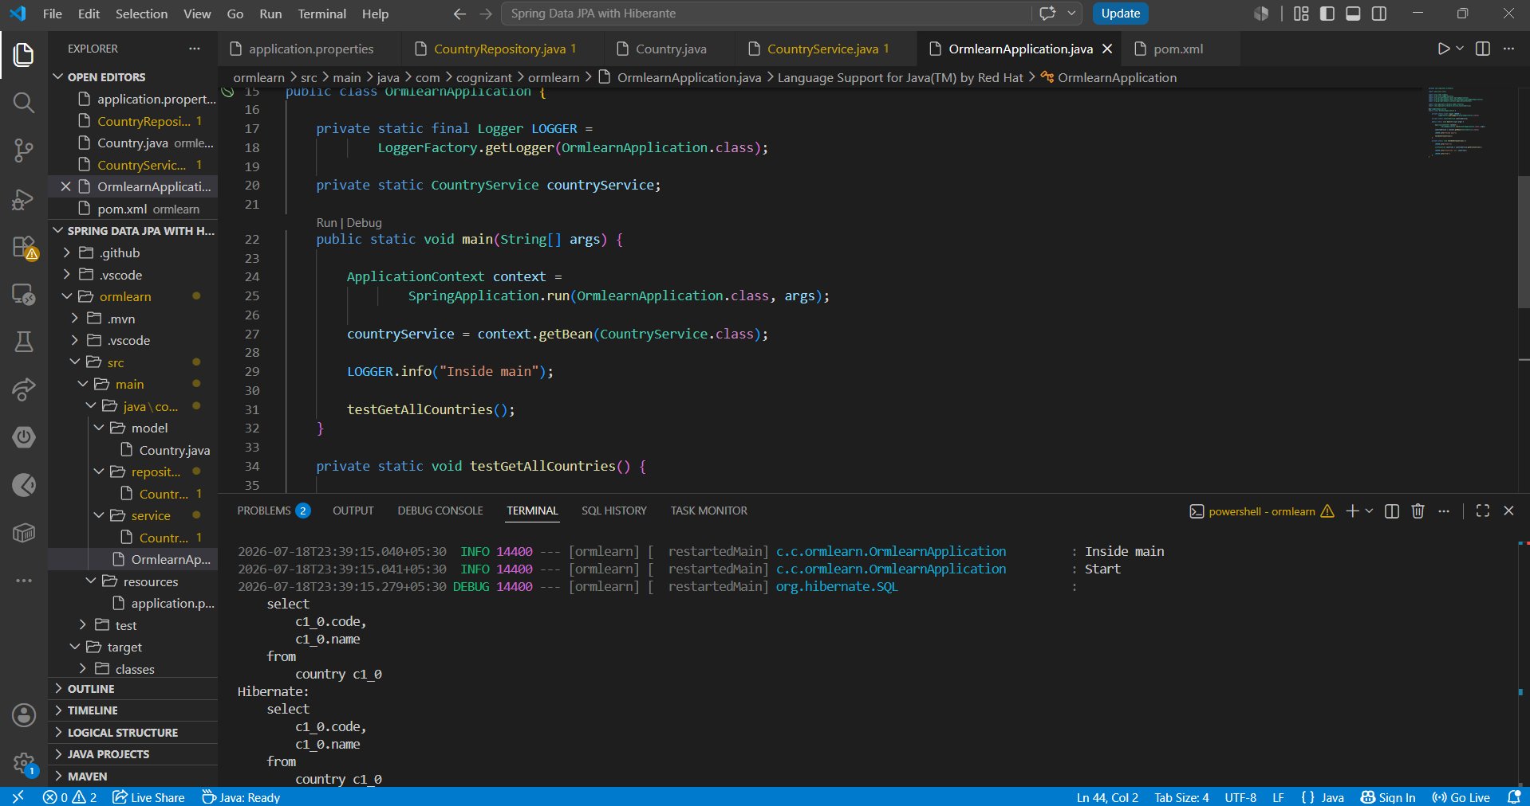

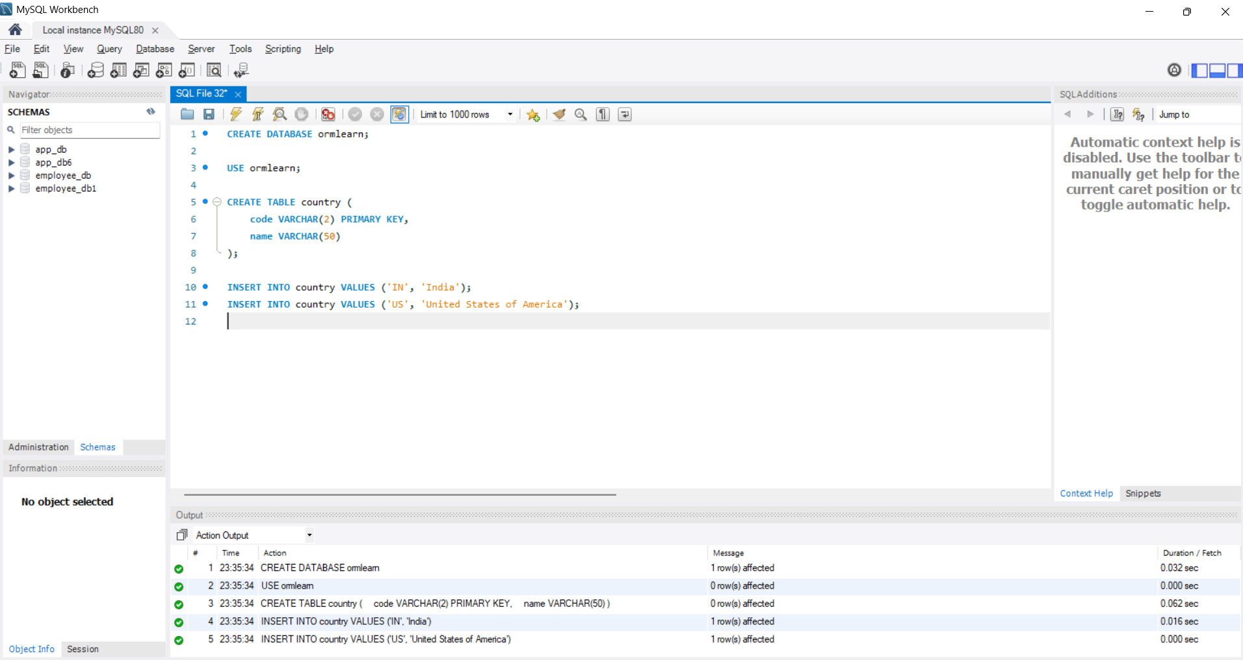
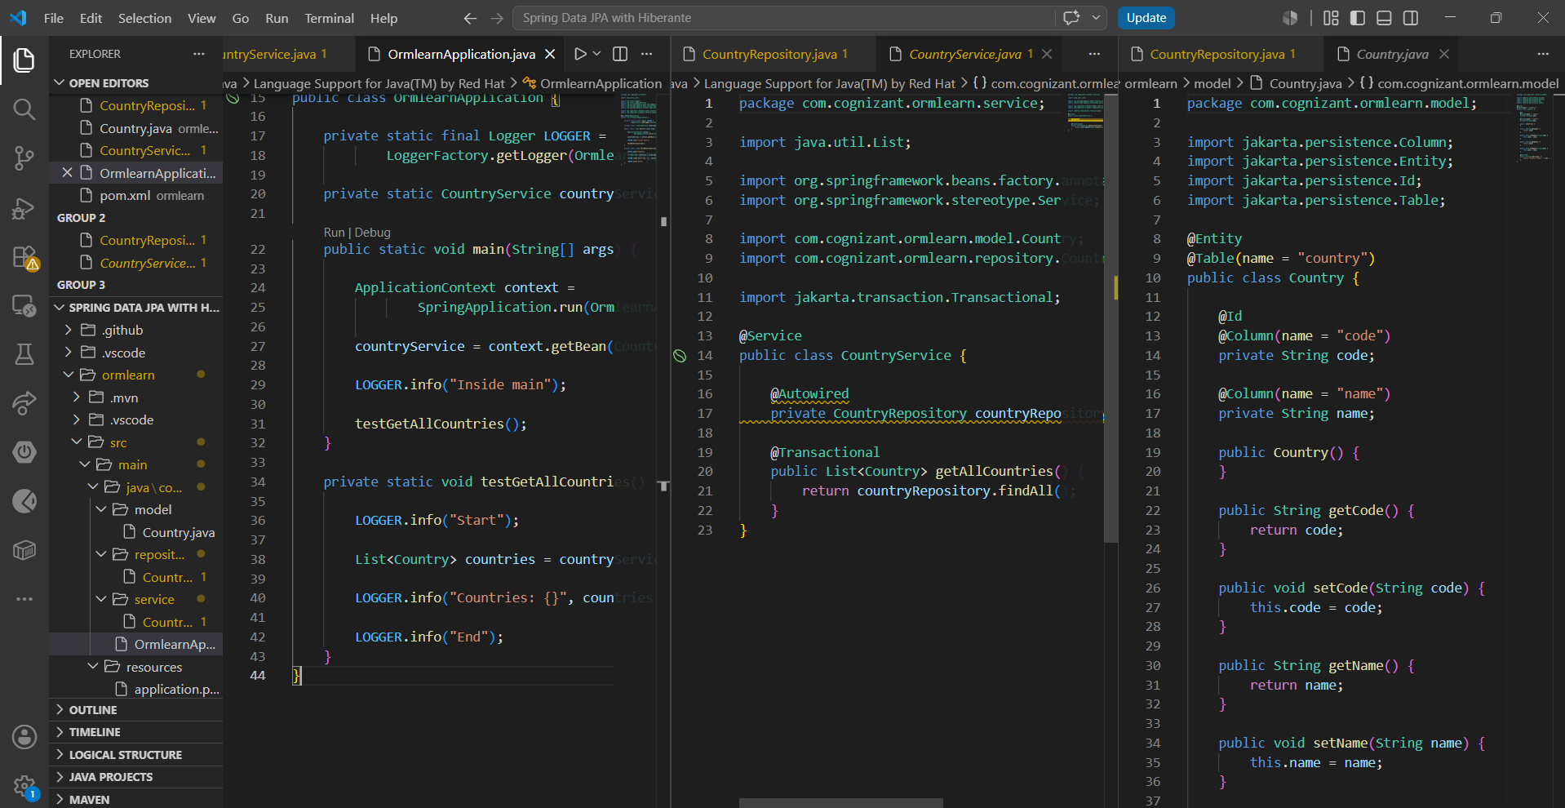

Feature | JPA | Hibernate | Spring Data JPA
Type | Specification | Framework | Spring Module
Developed By | Oracle / Java | Hibernate Team | Spring
Implements JPA | ❌ No | ✅ Yes | Uses Hibernate
ORM Tool | ❌ No | ✅ Yes | Uses Hibernate ORM
Boilerplate Code | High | Medium | Very Low
Transaction Management | No | Manual | Automatic (@Transactional)
CRUD Operations | Defines methods | Write Session code | Built-in methods (save(), findAll(), etc.)

